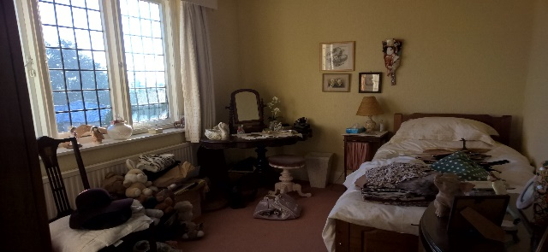
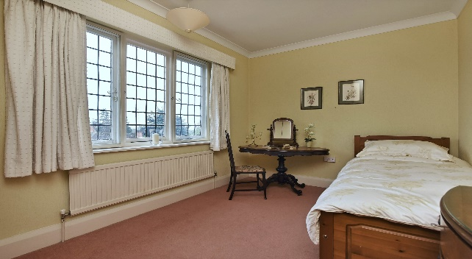
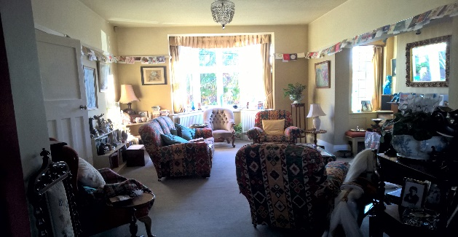
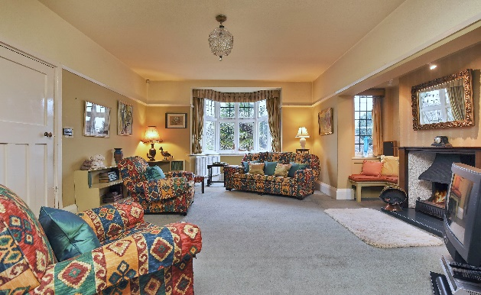

TEMPEST ROAD
We recently de-cluttered and dressed a lovely Edwardian property in the village of Birstall which the owner had lived in for over 50 years. Our team ensured the process of preparing the property for sale was smooth and empathetic given the long history of the property ownership. The owner’s daughter was very grateful for the 'assistance and understanding' from our team as her mother was struggling with the concept of a necessary move.
Once the property was de-cluttered and dressed it attracted strong interest and a successful offer was received within 24 hours of its reaching the market. Having spent in the region of £2200 with us on a property value of £525,000 to achieve this result, means that the vendor is able to move closer to her family very quickly.
To see more of the transformation photos, visit our gallery page on our website: https://www.lemonandlimeinteriors.co.uk/gallery-2/

